## PROGRAM DEFINITION

|  |
| --- |
|  |
| * Program untuk menambahkan Pricelist yang digunakan oleh Call Type di program CARE |

## RELATED TABLES

|  |  |
| --- | --- |
|  | **Access** |
| * HDM_PRICELIST_HD * HDM_PRICELIST_DT | * RW * RW |

## ROLES

|  |  |
| --- | --- |
|  | **Test** |
| * User yg mempunyai akses ke program |  |

## INITIAL PROCESS

|  |  |
| --- | --- |
|  | **Test** |
| * Set VAR_COMPANY_ID = Login User’s Company ID * Set VAR_USER_ID = Login User ID * Set VAR_LANGUAGE_ID = Login User’s Language ID * Jalankan RSP_GS_GET_PROPERTY_LIST dengan parameter, simpan hasil ke VAR_SELECTED_PROPERTY   + VAR_COMPANY_ID   + VAR_LANGUAGE_ID * Jalankan RSP_GS_GET_PROPERTY_DETAIL dengan parameter, simpan hasil ke VAR_SELECTED_PROPERTY_DETAIL   + VAR_COMPANY_ID   + VAR_SELECTED_PROPERTY.CPROPERTY_ID |  |

## TAB CURRENT PRICELIST

### USER INTERFACE

#### INITIAL VERSION

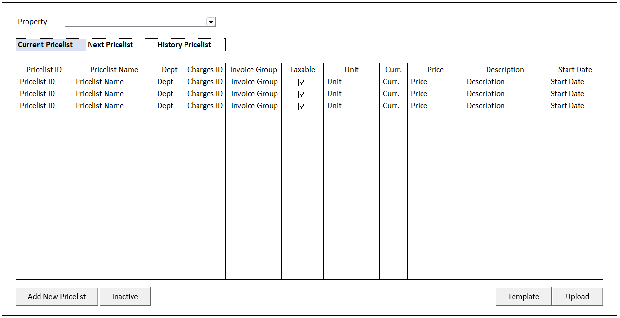

### INITIAL PROCESS

|  |  |
| --- | --- |
|  | **Test** |
| * Set **VAR_PRICELIST_STATUS** = ‘1’ * **Load Pricelist**   Jalankan RSP_HD_GET_PRICELIST_LIST dengan parameter, simpan hasil ke VAR_PRICELIST_LIST dan VAR_SELECTED_PRICELIST   * + VAR_COMPANY_ID   + VAR_SELECTED_PROPERTY.CPROPERTY_ID   + VAR_PRICELIST_STATUS   + VAR_LANGUAGE_ID |  |

### TAB DEFINITION

|  |  |  |
| --- | --- | --- |
| **Tab Name** | **Action** | **Enabled** |
| Current Pricelist | Go to TAB CURRENT PRICELIST  Jalankan **Load Pricelist** |  |
| Next Pricelist | Go to TAB NEXT PRICELIST  Jalankan **Load Pricelist** |  |
| History Pricelist | Go to TAB HISTORY PRICELIST  Jalankan **Load Pricelist** |  |

### BUTTON DEFINITION

|  |  |  |
| --- | --- | --- |
| **Button Name** | **Action** | **Enabled** |
| Add New Pricelist | Jalankan ADD NEW PRICELIST PROCESS |  |
| Inactive | Jalankan INACTIVE PROCESS | * + VAR_SELECTED_PRICELIST is not EMPTY |
| Template | Jalankan DOWNLOAD TEMPLATE PROCESS |  |
| Upload | Jalankan UPLOAD PROCESS |  |

### ROLES

|  |  |
| --- | --- |
|  | **Test** |
| * User yg punya akses ke program |  |

### DISPLAY PROCESS

#### FIELD DEFINITION

|  |  |  |  |
| --- | --- | --- | --- |
| **Name** | **Field** | **Type** | **Validation** |
| Property | CPROPERTY_ID | Combobox  Isi combobox dengan RSP_GS_GET_PROPERTY_LIST dengan parameter   * VAR_COMPANY_ID * VAR_USER_ID   Set ValueField = CPROPERTY_ID  Set TextField = CPROPERTY_NAME  Simpan hasil ke VAR_SELECTED_PROPERTY | On Value Changed,  IF Active Tab = ‘Current Pricelist’  **Load Pricelist**  Jalankan RSP_HD_GET_PRICELIST_LIST dengan parameter:   * + VAR_COMPANY_ID   + VAR_SELECTED_PROPERTY.CPROPERTY_ID   + VAR_PRICELIST_STATUS   + VAR_LANGUAGE_ID |
| **Pricelist Grid** |  | **Data**: VAR_PRICELIST_LIST | Allow: -  View Only  On Selected Changed,  Set VAR_SELECTED_PRICELIST = Selected row data  **Load Pricelist Detail**  Jalankan RSP_HD_GET_PRICELIST_DETAIL dengan parameter:   * + VAR_COMPANY_ID   + VAR_SELECTED_PROPERTY.CPROPERTY_ID   + VAR_SELECTED_PRICELIST.CPRICELIST_ID   + VAR_SELECTED_PRICELIST.CVALID_ID   + VAR_LANGUAGE_ID |
| Pricelist ID | CPRICELIST_ID | Textbox, Disabled |  |
| Pricelist Name | CPRICELIST_NAME | Textbox, Disabled |  |
| Dept | CDEPT_CODE | Textbox, Disabled |  |
| Charges ID | CCHARGES_ID | Textbox, Disabled |  |
| Invoice Group | CINVGRP_CODE | Textbox, Disabled |  |
| Taxable | LTAXABLE | Checkbox, Disabled |  |
| Unit | CUNIT | Textbox, Disabled |  |
| Curr. | CCURRENCY_CODE | Textbox, Disabled |  |
| Price | IPRICE | NumericTextbox, Disabled | Decimal Places = 2 |
| Description | CDESCRIPTION | Textbox, Disabled |  |
| Valid ID | CVALID_ID | Hidden |  |
| Start Date | CSTART_DATE  Set DSTART_DATE = Convert from CSTART_DATE from format “YYYYMMDD”  Set Display:  DSTART_DATE | DatePicker, Disabled |  |

### ADD NEW PRICELIST PROCESS

#### USER INTERFACE

#### INITIAL VERSION

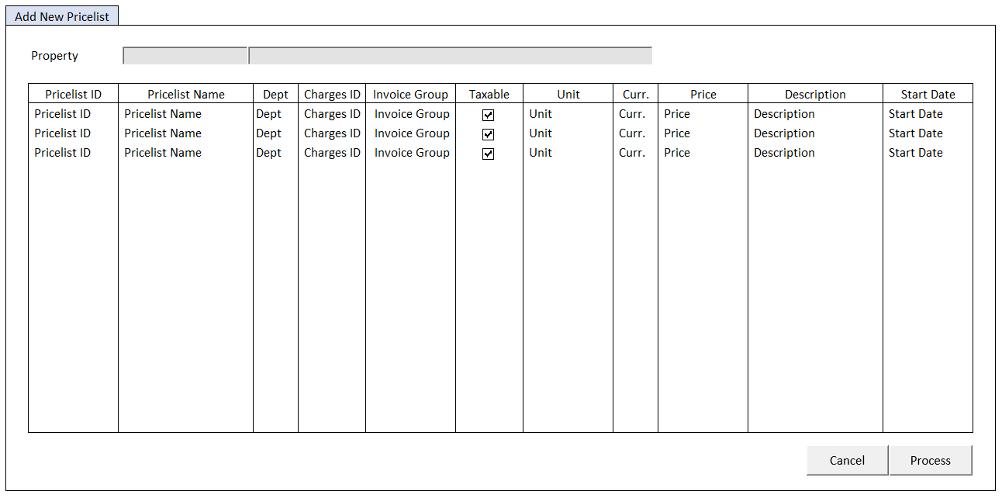

#### BUTTON DEFINITION

|  |  |  |
| --- | --- | --- |
| **Button Name** | **Action** | **Enabled** |
| Cancel | Jalankan CANCEL PROCESS |  |
| Process | Jalankan PROCESS |  |

#### INPUT PARAMETER

|  |  |
| --- | --- |
| **Parameter Name** | **Description** |
| PARAM_SELECTED_PROPERTY | VAR_SELECTED_PROPERTY from TAB CURRENT PRICELIST |

#### ROLES

|  |  |
| --- | --- |
|  | **Test** |
| * User yg punya akses ke program |  |

#### INITIAL PROCESS

|  |  |
| --- | --- |
|  | **Test** |
| * Load data from Input Parameter * Set **VAR_NEW_PRICELIST_LIST** = Empty List * Jalankan RSP_GS_GET_COMPANY_PARAM dengan parameter, simpan hasil ke VAR_COMPANY_PARAM   + VAR_COMPANY_ID   + VAR_USER_ID |  |

#### DISPLAY PROCESS

#### FIELD DEFINITION

|  |  |  |  |
| --- | --- | --- | --- |
| **Name** | **Field** | **Type** | **Validation** |
| Property | PARAM_SELECTED_PROPERTY. CPROPERTY_ID | Textbox, Disabled |  |
|  | PARAM_SELECTED_PROPERTY. CPROPERTY_NAME | Textbox, Disabled |  |
| **Add New Pricelist Grid** |  | Data: VAR_NEW_PRICELIST_LIST | Allow:  ADD 🡪   * Validate (see Validation Table) * Add new row to VAR_NEW_PRICELIST_LIST * Set CCURRENCY_CODE = VAR_SELECTED_PROPERTY_DETAIL. CCURRENCY   EDIT 🡪   * Validate (see Validation Table) * Edit selected selected data   DELETE 🡪 Remove selected row data from VAR_NEW_PRICELIST_LIST |
| Pricelist ID | CPRICELIST_ID | Textbox, Disabled, Required | Enabled: on ADD & EDIT |
| Pricelist Name | CPRICELIST_NAME | Textbox, Disabled, Required | Enabled: on ADD & EDIT |
| Dept | CDEPT_CODE | Textbox, Disabled, Required | Enabled: on ADD & EDIT  On Lost Focus  Go to 🡪 DEPARTMENT LOOKUP PROCESS  On value change, update:  CDEPT_CODE |
|  |  | Lookup, Disabled | Enabled: on ADD & EDIT  On Lookup Button clicked  Go to 🡪 DEPARTMENT LOOKUP PROCESS  On value change, update  CDEPT_CODE |
| Charges ID | CCHARGES_ID | Textbox, Disabled, Required | Enabled: on ADD & EDIT  On Lost Focus  Go to 🡪 CHARGES ID LOOKUP PROCESS  On value change, update:  CCHARGES_ID, CINVGRP_CODE, LTAXABLE |
|  |  | Lookup, Disabled | Enabled: on ADD & EDIT  On Lookup Button clicked  Go to 🡪 CHARGES ID LOOKUP PROCESS  On value change, update  CCHARGES_ID, CINVGRP_CODE, LTAXABLE |
| Invoice Group | CINVGRP_CODE | Textbox, Disabled |  |
| Taxable | LTAXABLE | Checkbox, Disabled |  |
| Unit | CUNIT | Textbox, Disabled, Required | Enabled: on ADD & EDIT |
| Curr. | CCURRENCY_CODE | Textbox, Disabled, Required |  |
| Price | IPRICE | NumericTextbox, Disabled, Required | No Arrows  Decimal Places = 2  Enabled: on ADD & EDIT |
| Description | CDESCRIPTION | Textbox, Disabled | Enabled: on ADD & EDIT |
| Start Date | CSTART_DATE  Set DSTART_DATE = Convert from CSTART_DATE from format “YYYYMMDD”  Set Display:  DSTART_DATE | DatePicker, Disabled, Required | Enabled: on ADD & EDIT |

#### DEPARTEMENT LOOKUP PROCESS

##### ON LOST FOCUS

###### PARAMETER

|  |  |
| --- | --- |
| **Parameter Name** | **Description** |
| CSEARCH_TEXT | Dept Field’s Value |

###### ACTION

|  |
| --- |
|  |
| * Run **GSL00700 – Department Lookup** dengan parameter:   + CSEARCH_TEXT * **Add New Pricelist GRID** stay on CRUD MODE * Set selected Add New Pricelist GRID’s row   CDEPT_CODE = LOOKUP_RETURN_VALUE.CDEPT_CODE |
|  |

##### BEFORE OPEN LOOKUP

###### PARAMETER

|  |  |
| --- | --- |
| **Parameter Name** | **Description** |
| CSEARCH_TEXT | ‘’ |

###### ACTION

|  |
| --- |
|  |
| * Run **PML00200 – Unit Charges Lookup** dengan parameter:   + CSEARCH_TEXT |
|  |

##### AFTER OPEN LOOKUP

###### CANCEL PROCESS

ACTION

|  |
| --- |
|  |
| * Close this POPUP * **Add New Pricelist GRID** stay on CRUD MODE |
|  |

###### LOOKUP SELECT DATA PROCESS

ACTION

|  |
| --- |
|  |
| * Close lookup * **Add New Pricelist GRID** stay on CRUD MODE * Set selected Add New Pricelist GRID’s row   CDEPT_CODE = LOOKUP_RETURN_VALUE.CDEPT_CODE |
|  |

#### CHARGES ID LOOKUP PROCESS

##### ON LOST FOCUS

###### PARAMETER

|  |  |
| --- | --- |
| **Parameter Name** | **Description** |
| CCOMPANY_ID | VAR_COMPANY_ID |
| CPROPERTY_ID | PARAM_SELECTED_PROPERTY.CPROPERTY_ID |
| CCHARGES_TYPE_ID | ‘01’ |
| CUSER_ID | VAR_USER_ID |
| CTAXABLE_TYPE | 0 |
| CACTIVE_TYPE | 1 |
| CSEARCH_TEXT | Charges ID’s field value |

###### ACTION

|  |
| --- |
|  |
| * Run **PML00200 – Unit Charges Lookup** dengan parameter:   + CCOMPANY_ID   + CPROPERTY_ID   + CCHARGES_TYPE_ID   + CUSER_ID   + CTAXABLE_TYPE   + CACTIVE_TYPE   + CSEARCH_TEXT * **Add New Pricelist GRID** stay on CRUD MODE * Set selected Add New Pricelist GRID’s row   CCHARGES_ID = LOOKUP_RETURN_VALUE.CCHARGES_ID  CINVGRP_CODE = LOOKUP_RETURN_VALUE.CINVGRP_CODE  LTAXABLE = LOOKUP_RETURN_VALUE.LTAXABLE |
|  |

##### BEFORE OPEN LOOKUP

###### PARAMETER

|  |  |
| --- | --- |
| **Parameter Name** | **Description** |
| CCOMPANY_ID | VAR_COMPANY_ID |
| CPROPERTY_ID | PARAM_SELECTED_PROPERTY.CPROPERTY_ID |
| CCHARGES_TYPE_ID | ‘01’ |
| CUSER_ID | VAR_USER_ID |
| CTAXABLE_TYPE | 0 |
| CACTIVE_TYPE | 1 |

###### ACTION

|  |
| --- |
|  |
| * Run **PML00200 – Unit Charges Lookup** dengan parameter:   + CCOMPANY_ID   + CPROPERTY_ID   + CCHARGES_TYPE_ID   + CUSER_ID   + CTAXABLE_TYPE   + CACTIVE_TYPE |
|  |

##### AFTER OPEN LOOKUP

###### CANCEL PROCESS

ACTION

|  |
| --- |
|  |
| * Close this POPUP * **Add New Pricelist GRID** stay on CRUD MODE |
|  |

###### LOOKUP SELECT DATA PROCESS

ACTION

|  |
| --- |
|  |
| * Close lookup * **Add New Pricelist GRID** stay on CRUD MODE * Set selected Add New Pricelist GRID’s row   CCHARGES_ID = LOOKUP_RETURN_VALUE.CCHARGES_ID  CINVGRP_CODE = LOOKUP_RETURN_VALUE.CINVGRP_CODE  LTAXABLE = LOOKUP_RETURN_VALUE.LTAXABLE |
|  |

#### VALIDATION

|  |  |  |
| --- | --- | --- |
| **Field** | **Condition** | **Validation Message** |
| Pricelist ID | CPRICELIST_ID is Empty | Please fill Pricelist ID! |
| Pricelist Name | CPRICELIST_NAME is Empty | Please fill Pricelist Name! |
| Dept | CDEPT_CODE is Empty | Please fill Department! |
| Charges ID | CCHARGES_ID is Empty | Please fill Charges ID! |
| Curr. | CCURRENCY_CODE is Empty | Please fill Currency! |
| Unit | CUNIT is Empty | Please fill unit! |
| Price | IPRICE <= 0 | Price cannot be 0 or negative! |
| Start Date | CSTART_DATE is Empty | Please fill Start Date! |

#### CANCEL PROCESS

##### ACTION

|  |
| --- |
|  |
| * Close this POPUP |
|  |

#### PROCESS

##### ACTION

|  |
| --- |
|  |
| * **Validate** (See VALIDATION table)   IF Success, jalankan process  IF Failed, stay on popup   * Set **Progess bar step** = 4 * Set **VAR_KEY_GUID** = New GUID * Set **VAR_ERROR_COUNT** = 0 * Reset Progress Bar |
| **BEGIN TRANSACTION**   * Buat temporary table   CREATE TABLE #NEW_PRICELIST(  NO INT NOT NULL  , CPRICELIST_ID VARCHAR(20) NOT NULL  , CPRICELIST_NAME NVARCHAR(100) NOT NULL  , CDEPT_CODE VARCHAR(20) NOT NULL  , CCHARGES_ID VARCHAR(20) NOT NULL  , CUNIT VARCHAR(10) NOT NULL  , CCURRENCY_CODE VARCHAR(3) NOT NULL  , IPRICE INT NOT NULL  , CDESCRIPTION NVARCHAR(500)  , CSTART_DATE VARCHAR(8)  )   * Insert **VAR_NEW_PRICELIST_LIST** into #NEW_PRICELIST * **Add New Pricelist** * Jalankan RSP_HD_ADD_PRICELIST_PROCESS dengan parameter   @CCOMPANY_ID = VAR_COMPANY_ID  @CPROPERTY_ID = PARAM_SELECTED_PROPERTY.CPROPERTY_ID  @CUSER_ID = VAR_USER_ID  @CKEY_GUID = VAR_KEY_GUID  **COMPLETE TRANSACTION** |
| IF SUCCESS   * Close this POPUP * Refresh **Pricelist Grid** di TAB CURRENT PRICELIST |
| IF ERROR   * Show Error Message * Stay in this POPUP |

### INACTIVE PROCESS

#### ACTION

|  |
| --- |
|  |
| * **Inactive Pricelist**   Jalankan RSP_HD_INACTIVE_PRICELIST dengan parameter,  @CCOMPANY_ID = VAR_COMPANY_ID  @CPROPERTY_ID = VAR_SELECTED_PROPERTY.CPROPERTY_ID  @CPRICELIST_ID = ‘Pricelist ID’  @CVALID_ID = ‘Valid ID’  @CUSER_ID = VAR_USER_ID |
| * Refresh **Pricelist Grid** di TAB CURRENT PRICELIST |

### DOWNLOAD TEMPLATE PROCESS

#### ACTION

|  |
| --- |
|  |
| * Download Pricelist File from Server   Download Filename: ‘PricelistTemplate.xlsx   * Tampilkan file directory untuk proses **Save As Download** oleh user |
|  |

### UPLOAD PROCESS

#### USER INTERFACE

#### INITIAL VERSION

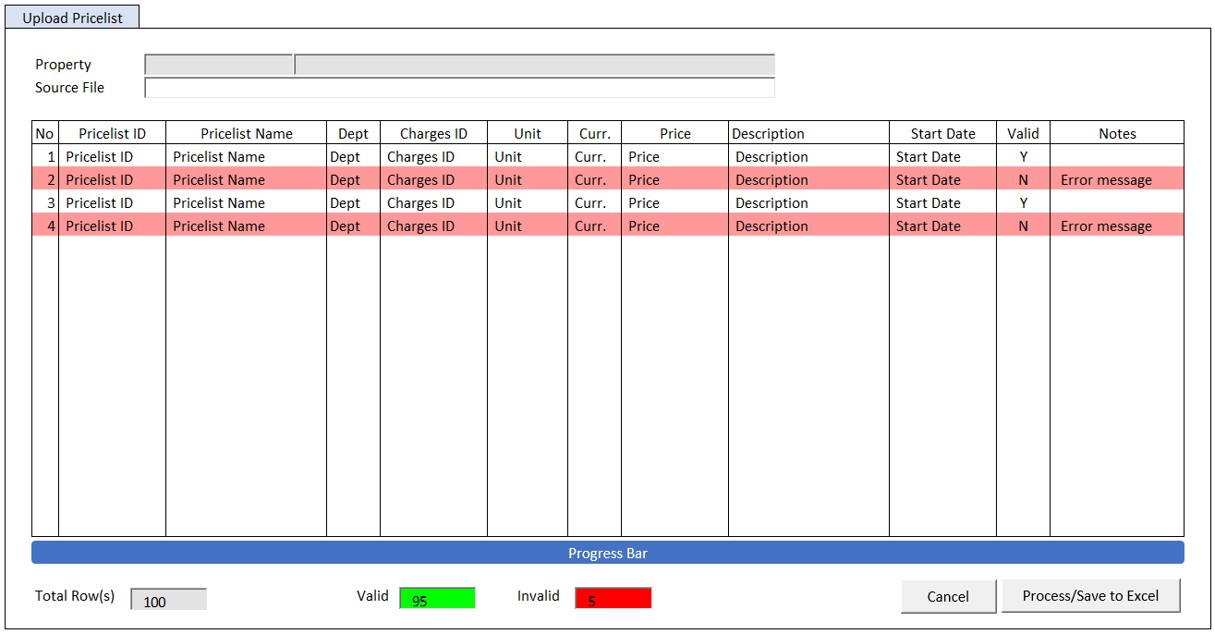

#### BUTTON DEFINITION

|  |  |  |
| --- | --- | --- |
| **Button Name** | **Action** | **Enabled** |
| Cancel | Jalankan CANCEL PROCESS |  |
| Process | Jalankan PROCESS | * XLSX File Load Successfully * VAR_TOTAL_ROWS > 0 |
| Save to Excel | Jalankan SAVE TO EXCEL PROCESS | * Handled Error found in PROCESS |

#### INPUT PARAMETER

|  |  |
| --- | --- |
| **Parameter Name** | **Description** |
| PARAM_SELECTED_PROPERTY | VAR_SELECTED_PROPERTY from TAB CURRENT PRICELIST |

#### ROLES

|  |  |
| --- | --- |
|  | **Test** |
| * User yg punya akses ke program |  |

#### INITIAL PROCESS

|  |  |
| --- | --- |
|  | **Test** |
| * Load data from Input Parameter * Set **VAR_SOURCE_FILE** = ‘’ * Set **VAR_TOTAL_ROWS** = 0 * Set **VAR_VALID_ROWS** = 0 * Set **VAR_INVALID_ROWS** = 0 * Set Focus pada Source File Input |  |

#### DISPLAY PROCESS

#### FIELD DEFINITION

|  |  |  |  |
| --- | --- | --- | --- |
| **Name** | **Field** | **Type** | **Validation** |
| Property | PARAM_SELECTED_PROPERTY. CPROPERTY_ID | Textbox, Disabled |  |
|  | PARAM_SELECTED_PROPERTY. CPROPERTY_NAME | Textbox, Disabled |  |
| Source File | VAR_SOURCE_FILE | FileInput  Simpan data ke **VAR_UPLOAD_LIST, VAR_TOTAL_ROWS** | Accepts: .xlsx (Microsoft Excel)  Read Excel dari SheetName ‘SLACallType’  IF VAR_SOURCE_FILE is not Excel File   * Show message “File Type must Microsoft Excel .xlsx!”   IF VAR_SOURCE_FILE is empty   * Show message “File is empty!” |
| **Add New Pricelist Grid** |  | **Data:** VAR_UPLOAD_LIST / VAR_RESULT | Allow: -  ViewOnly  If CVALID = ‘N’, RenderRow with background color ‘red’ |
| No | INO | Textbox, Disabled |  |
| Pricelist ID | CPRICELIST_ID | Textbox, Disabled |  |
| Pricelist Name | CPRICELIST_NAME | Textbox, Disabled |  |
| Dept | CDEPT_CODE | Textbox, Disabled |  |
| Charges ID | CCHARGES_ID | Textbox, Disabled |  |
| Curr. | CCURRENCY_CODE | Textbox, Disabled |  |
| Unit | CUNIT | Textbox, Disabled |  |
| Price | IPRICE | NumericTextbox, Disabled | Decimal Places = 2 |
| Description | CDESCRIPTION | Textbox, Disabled |  |
| Start Date | CSTART_DATE  Set DSTART_DATE = Convert from CSTART_DATE from format “YYYYMMDD”  Set Display:  DSTART_DATE | DatePicker, Disabled |  |
| Valid | CVALID | Textbox, Disabled |  |
| Notes | CNOTES | Textbox, Disabled |  |
| **Footer** |  |  |  |
| Total Rows | VAR_TOTAL_ROWS | Textbox, Disabled |  |
| Valid | VAR_VALID_ROWS | Textbox, Disabled  Background Color: Green | Update after PROCESS |
| Invalid | VAR_INVALID_ROWS | Textbox, Disabled  Background Color: Red | Update after PROCESS |

#### CANCEL PROCESS

##### ACTION

|  |
| --- |
|  |
| * Close this POPUP * Refresh **Pricelist Grid** di TAB CURRENT PRICELIST |
|  |

#### PROCESS

##### ACTION

|  |
| --- |
|  |
| * **Validate** (See VALIDATION table)   IF Success, jalankan process  IF Failed, stay on popup   * Set **Progess bar step** = 4 * Set **VAR_KEY_GUID** = New GUID * Set **VAR_ERROR_COUNT** = 0 * Reset Progress Bar |
| **BEGIN TRANSACTION**   * Buat temporary table   CREATE TABLE #UPLOAD_PRICELIST(  NO INT NOT NULL  , CPRICELIST_ID VARCHAR(20) NOT NULL  , CPRICELIST_NAME NVARCHAR(100) NOT NULL  , CDEPT_CODE VARCHAR(20) NOT NULL  , CCHARGES_ID VARCHAR(20) NOT NULL  , CUNIT VARCHAR(10) NOT NULL  , CCURRENCY_CODE VARCHAR(3) NOT NULL  , IPRICE INT NOT NULL  , CDESCRIPTION NVARCHAR(500)  , CSTART_DATE VARCHAR(8)  )   * Insert **VAR_NEW_PRICELIST_LIST** into #UPLOAD_PRICELIST * **Add New Pricelist** * Jalankan RSP_HD_UPLOAD_PRICELIST_PROCESS dengan parameter   @CCOMPANY_ID = VAR_COMPANY_ID  @CPROPERTY_ID = PARAM_SELECTED_PROPERTY.CPROPERTY_ID  @CUSER_ID = VAR_USER_ID  @CKEY_GUID = VAR_KEY_GUID   * Set Upload Grid **DATA SOURCE** = **VAR_RESULT**   **COMPLETE TRANSACTION** |
| IF SUCCESS   * Close this POPUP * Refresh **Pricelist Grid** di TAB CURRENT PRICELIST |
| IF ERROR   * Stay on this POPUP |

#### SAVE TO EXCEL PROCESS

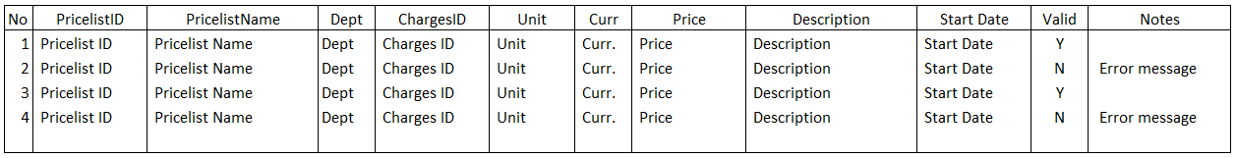

##### ACTION

|  |
| --- |
|  |
| * **Generate Template Process**   Buat template dengan detail sebagai berikut:  No  PricelistID  PricelistName  Dept  ChargesID  Unit  Curr  Price  Description  StartDate  Valid  Notes  Set Excel Sheet Name = ‘Pricelist’   * Create File Excel * Tampilkan file directory untuk proses **Save As Download** oleh user |

## TAB NEXT PRICELIST

### USER INTERFACE

#### INITIAL VERSION

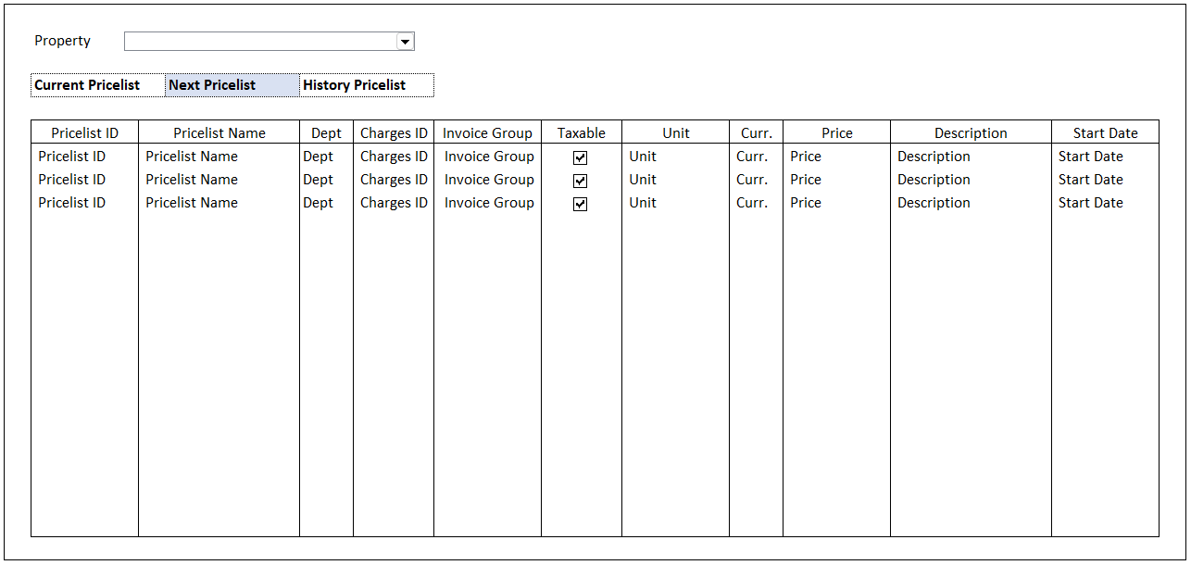

### INITIAL PROCESS

|  |  |
| --- | --- |
|  | **Test** |
| * Set **VAR_PRICELIST_STATUS** = ‘2’ * **Load Pricelist**   Jalankan RSP_HD_GET_PRICELIST_LIST dengan parameter, simpan hasil ke VAR_PRICELIST_LIST dan VAR_SELECTED_PRICELIST   * + VAR_COMPANY_ID   + VAR_SELECTED_PROPERTY.CPROPERTY_ID   + VAR_PRICELIST_STATUS   + VAR_LANGUAGE_ID |  |

### ROLES

|  |  |
| --- | --- |
|  | **Test** |
| * User yg punya akses ke program |  |

### DISPLAY PROCESS

#### FIELD DEFINITION

|  |  |  |  |
| --- | --- | --- | --- |
| **Name** | **Field** | **Type** | **Validation** |
| Property | CPROPERTY_ID | Combobox  Isi combobox dengan RSP_GS_GET_PROPERTY_LIST dengan parameter   * VAR_COMPANY_ID * VAR_USER_ID   Set ValueField = CPROPERTY_ID  Set TextField = CPROPERTY_NAME  Simpan hasil ke VAR_SELECTED_PROPERTY | On Value Changed,  IF Active Tab = ‘Next Pricelist’  **Load Pricelist**  Jalankan RSP_HD_GET_PRICELIST_LIST dengan parameter:   * + VAR_COMPANY_ID   + VAR_SELECTED_PROPERTY.CPROPERTY_ID   + VAR_PRICELIST_STATUS   + VAR_LANGUAGE_ID |
| **Pricelist Grid** |  | **Data**: VAR_PRICELIST_LIST | Allow:  ADD 🡪 Jalankan Add New Process  EDIT 🡪 Jalankan Edit Process  DELETE 🡪 Jalankan Delete Process  On Selected Changed,  Set VAR_SELECTED_PRICELIST = Selected row data  **Load Pricelist Detail**  Jalankan RSP_HD_GET_PRICELIST_DETAIL dengan parameter:   * + VAR_COMPANY_ID   + VAR_SELECTED_PROPERTY.CPROPERTY_ID   + VAR_SELECTED_PRICELIST.CPRICELIST_ID   + VAR_SELECTED_PRICELIST.CVALID_ID   + VAR_LANGUAGE_ID |
| Pricelist ID | CPRICELIST_ID | Textbox, Disabled | Enabled: on ADD  On Lost Focus  Go to 🡪 PRICELIST LOOKUP PROCESS  On value change, update:  CPRICELIST_ID, CPRICELIST_NAME, CCHARGES_ID, CDEPT_CODE, CINVGRP_CODE, LTAXABLE, CUNIT, CDESCRIPTION, CACTIVE_START_DATE |
|  |  | Lookup, Disabled | Enabled: on ADD  On Lookup Button clicked  Go to 🡪 PRICELIST LOOKUP PROCESS  On value change, update:  CPRICELIST_ID, CPRICELIST_NAME, CCHARGES_ID, CDEPT_CODE, CINVGRP_CODE, LTAXABLE, CUNIT, CDESCRIPTION, CACTIVE_START_DATE |
| Pricelist Name | CPRICELIST_NAME | Textbox, Disabled |  |
| Dept | CDEPT_CODE | Textbox, Disabled |  |
| Charges ID | CCHARGES_ID | Textbox, Disabled |  |
| Invoice Group | CINVGRP_CODE | Textbox, Disabled |  |
| Taxable | LTAXABLE | Checkbox, Disabled |  |
| Unit | CUNIT | Textbox, Disabled |  |
| Curr. | CCURRENCY_CODE | Textbox, Disabled |  |
| Price | IPRICE | NumericTextbox, Disabled | No Arrows  Decimal Places = 2  Enabled: on ADD & EDIT |
| Description | CDESCRIPTION | Textbox, Disabled |  |
| Valid ID | CVALID_ID | Hidden |  |
| Last Start Date | CACTIVE_START_DATE | Hidden |  |
| Start Date | CSTART_DATE  Set DSTART_DATE = Convert from CSTART_DATE from format “YYYYMMDD”  Set Display:  DSTART_DATE | DatePicker, Disabled | Enabled: on ADD & EDIT  Default Value = Today  Min Value = CACTIVE_START_DATE + 1 |

### ADD NEW PROCESS

#### ACTION

|  |
| --- |
|  |
| * Set **VAR_SAVE_MODE** = ‘ADD’ * Set **CCURRENCY_CODE** = VAR_SELECTED_PROPERTY_DETAIL.CCURRENCY * Enabled Fields: ‘Pricelist ID’, ‘Lookup Pricelist ID’, ‘Price’, ‘Start Date’ * Set focus to column: ‘Pricelist ID’ |
| * Proses:   + ‘Save’ 🡪 Go To SAVE & VALIDATION PROCESS   + ‘Cancel’ 🡪 Go To DISPLAY PROCESS |

### EDIT PROCESS

#### ACTION

|  |
| --- |
|  |
| * Set **VAR_SAVE_MODE** = ‘EDIT’ * Enabled Fields: ‘Price’, ‘Start Date’ * Set focus to column: ‘Price’ |
| * Proses:   + ‘Save’ 🡪 Go To SAVE & VALIDATION PROCESS   + ‘Cancel’ 🡪 Go To DISPLAY PROCESS |

### DELETE PROCESS

#### ACTION

|  |
| --- |
|  |
| * Set **VAR_SAVE_MODE** = ‘DELETE’ |
| * **Delete Pricelist**   Jalankan RSP_HD_MAINTAIN_PRICELIST dengan parameter,  @CCOMPANY_ID = VAR_COMPANY_ID  @CPROPERTY_ID = VAR_SELECTED_PROPERTY.CPROPERTY_ID  @CPRICELIST_ID = ‘Pricelist ID’  @CPRICELIST_NAME = ‘Pricelist Name’  @CDEPT_CODE = ‘Dept’  @CCHARGES_ID = ‘Charges ID’  @CUNIT = ‘Unit’  @CCURRENCY_CODE = ‘Curr.’  @IPRICE = ‘Price’  @CDESCRIPTION = ‘Description’  @CVALID_ID = ‘Valid ID’  @CSTART_DATE = ‘Start Date’  @CACTION = ‘DELETE’  @CUSER_ID = VAR_USER_ID |

### SAVE & VALIDATION PROCESS

#### VALIDATION

|  |  |  |
| --- | --- | --- |
| **Field** | **Condition** | **Validation Message** |
| Pricelist ID | CPRICELIST_ID is Empty | Please fill Pricelist ID! |
| Pricelist Name | CPRICELIST_NAME is Empty | Please fill Pricelist Name! |
| Dept | CDEPT_CODE is Empty | Please fill Department! |
| Charges ID | CCHARGES_ID is Empty | Please fill Charges ID! |
| Unit | CUNIT is Empty | Please fill Unit! |
| Curr. | CCURRENCY_CODE is Empty | Please fill Currency! |
| Price | IPRICE <= 0 | Price cannot be 0 or negative! |
| Start Date | CSTART_DATE is Empty | Please fill Start Date! |

#### ACTION

|  |
| --- |
|  |
| * **Validate** (See VALIDATION table)   IF Success, jalankan Save Pricelist  IF Failed, stay on Add/Edit Process   * **Save Pricelist**   Jalankan RSP_HD_MAINTAIN_PRICELIST dengan parameter,  @CCOMPANY_ID = VAR_COMPANY_ID  @CPROPERTY_ID = VAR_SELECTED_PROPERTY.CPROPERTY_ID  @CPRICELIST_ID = ‘Pricelist ID’  @CPRICELIST_NAME = ‘Pricelist Name’  @CDEPT_CODE = ‘Dept’  @CCHARGES_ID = ‘Charges ID’  @CUNIT = ‘Unit’  @CCURRENCY_CODE = ‘Curr.’  @IPRICE = ‘Price’  @CDESCRIPTION = ‘Description’  @CVALID_ID = ‘Valid ID’ (IF VAR_SAVE_MODE = ‘ADD’, it will be ‘’)  @CSTART_DATE = ‘Start Date’  @CACTION = VAR_SAVE_MODE  @CUSER_ID = VAR_USER_ID   * If VAR_SAVE_MODE = ‘ADD’ Simpan CVALID_ID result from RSP_HD_MAINTAIN_PRICELIST ke SAVE_PARAMETER.ENTITY.CVALID_ID (untuk digunakan dalam R_GetRecord) |
| * Go to DISPLAY PROCESS |

### PRICELIST LOOKUP PROCESS

#### ON LOST FOCUS

##### PARAMETER

|  |  |
| --- | --- |
| **Parameter Name** | **Description** |
| CCOMPANY_ID | VAR_COMPANY_ID |
| CPROPERTY_ID | VAR_SELECTED_PROPERTY.CPROPERTY_ID from TAB NEXT PRICELIST |
| CSTATUS | ‘0’ |
| CTAXABLE | ‘0’ |
| CUSER_ID | VAR_USER_ID |
| CSEARCH_TEXT | Pricelist ID’s field value |

##### ACTION

|  |
| --- |
|  |
| * Run **HDL00100 – Pricelist Lookup** dengan parameter:   + CCOMPANY_ID   + CPROPERTY_ID   + CSTATUS   + CTAXABLE   + CUSER_ID   + CSEARCH_TEXT * **Pricelist Grid** stay on CRUD MODE * Set selected **Pricelist Grid**’s row   CPRICELIST_ID = LOOKUP_RETURN_VALUE.CPRICELIST_ID  CPRICELIST_NAME = LOOKUP_RETURN_VALUE.CPRICELIST_NAME  CDEPT_CODE = LOOKUP_RETURN_VALUE.CDEPT_CODE  CCHARGES_ID = LOOKUP_RETURN_VALUE.CCHARGES_ID  CUNIT = LOOKUP_RETURN_VALUE.CUNIT  CDESCRIPTION = LOOKUP_RETURN_VALUE.CDESCRIPTION  CACTIVE_START_DATE = LOOKUP_RETURN_VALUE.CACTIVE_START_DATE  CINVGRP_CODE = LOOKUP_RETURN_VALUE.CINVGRP_CODE  LTAXABLE = LOOKUP_RETURN_VALUE.LTAXABLE |
|  |

#### BEFORE OPEN LOOKUP

##### PARAMETER

|  |  |
| --- | --- |
| **Parameter Name** | **Description** |
| CCOMPANY_ID | VAR_COMPANY_ID |
| CPROPERTY_ID | VAR_SELECTED_PROPERTY.CPROPERTY_ID from TAB NEXT PRICELIST |
| CSTATUS | ‘0’ |
| CTAXABLE | ‘0’ |
| CUSER_ID | VAR_USER_ID |

##### ACTION

|  |
| --- |
|  |
| * Run **HDL00100 – Pricelist Lookup** dengan parameter:   + CCOMPANY_ID   + CPROPERTY_ID   + CSTATUS   + CTAXABLE   + CUSER_ID |
|  |

#### AFTER OPEN LOOKUP

##### CANCEL PROCESS

###### ACTION

|  |
| --- |
|  |
| * Close this POPUP * **Pricelist Grid** stay on CRUD MODE |
|  |

##### LOOKUP SELECT DATA PROCESS

###### ACTION

|  |
| --- |
|  |
| * Close lookup * **Pricelist Grid** stay on CRUD MODE * Set selected **Pricelist Grid**’s row   CPRICELIST_ID = LOOKUP_RETURN_VALUE.CPRICELIST_ID  CPRICELIST_NAME = LOOKUP_RETURN_VALUE.CPRICELIST_NAME  CDEPT_CODE = LOOKUP_RETURN_VALUE.CDEPT_CODE  CCHARGES_ID = LOOKUP_RETURN_VALUE.CCHARGES_ID  CUNIT = LOOKUP_RETURN_VALUE.CUNIT  CDESCRIPTION = LOOKUP_RETURN_VALUE.CDESCRIPTION  CACTIVE_START_DATE = LOOKUP_RETURN_VALUE.CACTIVE_START_DATE  CINVGRP_CODE = LOOKUP_RETURN_VALUE.CINVGRP_CODE  LTAXABLE = LOOKUP_RETURN_VALUE.LTAXABLE |
|  |

## TAB HISTORY PRICELIST

### USER INTERFACE

#### INITIAL VERSION

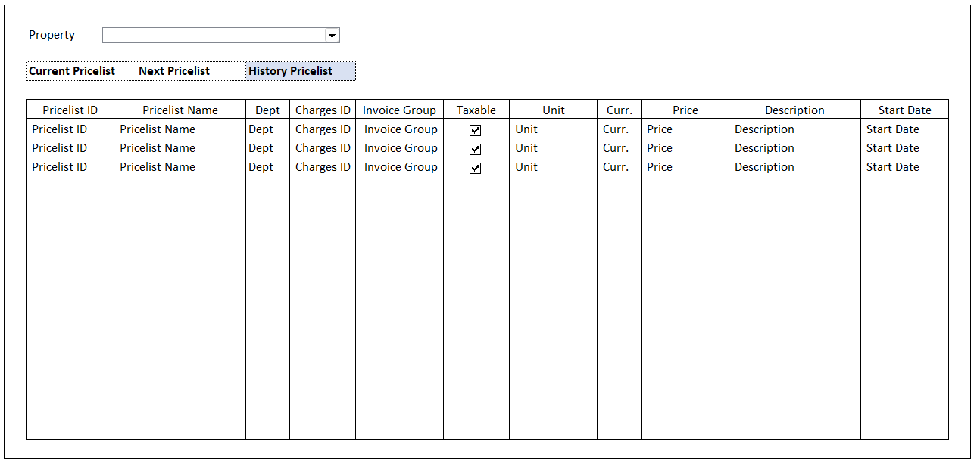

### INITIAL PROCESS

|  |  |
| --- | --- |
|  | **Test** |
| * Set **VAR_PRICELIST_STATUS** = ‘3’ * **Load Pricelist**   Jalankan RSP_HD_GET_PRICELIST_LIST dengan parameter, simpan hasil ke VAR_PRICELIST_LIST dan VAR_SELECTED_PRICELIST   * + VAR_COMPANY_ID   + VAR_SELECTED_PROPERTY.CPROPERTY_ID   + VAR_PRICELIST_STATUS   + VAR_LANGUAGE_ID |  |

### ROLES

|  |  |
| --- | --- |
|  | **Test** |
| * User yg punya akses ke program |  |

### DISPLAY PROCESS

#### FIELD DEFINITION

|  |  |  |  |
| --- | --- | --- | --- |
| **Name** | **Field** | **Type** | **Validation** |
| Property | CPROPERTY_ID | Combobox  Isi combobox dengan RSP_GS_GET_PROPERTY_LIST dengan parameter   * VAR_COMPANY_ID * VAR_USER_ID   Set ValueField = CPROPERTY_ID  Set TextField = CPROPERTY_NAME  Simpan hasil ke VAR_SELECTED_PROPERTY | On Value Changed,  IF Active Tab = ‘History Pricelist’  **Load Pricelist**  Jalankan RSP_HD_GET_PRICELIST_LIST dengan parameter:   * + VAR_COMPANY_ID   + VAR_SELECTED_PROPERTY.CPROPERTY_ID   + VAR_PRICELIST_STATUS   + VAR_LANGUAGE_ID |
| **Pricelist Grid** |  | **Data**: VAR_PRICELIST_LIST | Allow: -  View Only  On Selected Changed,  Set VAR_SELECTED_PRICELIST = Selected row data  **Load Pricelist Detail**  Jalankan RSP_HD_GET_PRICELIST_DETAIL dengan parameter:   * + VAR_COMPANY_ID   + VAR_SELECTED_PROPERTY.CPROPERTY_ID   + VAR_SELECTED_PRICELIST.CPRICELIST_ID   + VAR_SELECTED_PRICELIST.CVALID_ID   + VAR_LANGUAGE_ID |
| Pricelist ID | CPRICELIST_ID | Textbox, Disabled |  |
| Pricelist Name | CPRICELIST_NAME | Textbox, Disabled |  |
| Dept | CDEPT_CODE | Textbox, Disabled |  |
| Charges ID | CCHARGES_ID | Textbox, Disabled |  |
| Invoice Group | CINVGRP_CODE | Textbox, Disabled |  |
| Taxable | LTAXABLE | Checkbox, Disabled |  |
| Unit | CUNIT | Textbox, Disabled |  |
| Curr. | CCURRENCY_CODE | Textbox, Disabled |  |
| Price | IPRICE | NumericTextbox, Disabled | Decimal Places = 2 |
| Description | CDESCRIPTION | Textbox, Disabled |  |
| Valid ID | CVALID_ID | Hidden |  |
| Start Date | CSTART_DATE  Set DSTART_DATE = Convert from CSTART_DATE from format “YYYYMMDD”  Set Display:  DSTART_DATE | DatePicker, Disabled |  |

# CR LIST

|  |  |  |
| --- | --- | --- |
| **CR** | **Description** | **Notes** |
|  |  |  |